### **Effects of Temperature on Development, Survival, and Morphology of Antlion Larvae (*Myrmeleon almohadarum* and *Myrmeleon hyalinu*s)**

or

### **Thermal Influence on Development and Survival of Antlion Species: A Laboratory Study**

or

### **Temperature-Driven Development and Morphological Plasticity in Antlion Larvae**

or

**Temperature has variable effects on life history and behaviour in Antlions**

Hanna Serediuk1,2, Maria Paniw1 and John Jackson1

1- *Department of Conservation Biology and Global Change, Estación Biológica de Doñana (EBD-CSIC), Seville, 41001 Spain*

2- *State Museum of Natural History NASU, Lviv, 79008**Ukraine*

### *Temperature plays a crucial role in insect development, survival, and morphology. In this study, we investigated the effects of different temperature regimes on the development, survival, and morphology of two antlion species, Myrmeleon almohadarum and Myrmeleon hyalinus. Larvae were reared under five temperature conditions: 25 °C, 27 °C, 29 °C, 33 °C, and a fluctuating regime of 27 °C (night) / 39 °C (day). We recorded developmental duration, survival rates, adult body size, forewing length, body mass, and morphological abnormalities.*

### *Our results showed that higher temperatures (29 °C and 33 °C) significantly accelerated larval development but also increased mortality, particularly in M. hyalinus. M. almohadarum exhibited greater thermal tolerance, showing higher survival rates and fewer morphological defects. The fluctuating temperature regime (27/39 °C) mitigated some negative effects of high temperatures, improving survival and reducing the incidence of malformed wings. Additionally, temperature influenced larval behaviour, affecting pit trap size and feeding activity.*

### *These findings suggest that temperature fluctuations may help buffer the negative impacts of extreme heat, highlighting the importance of natural thermal variability in antlion survival and development. Our results contribute to understanding how climate change may impact these species and their ecological roles in arid environments.*

### **Keywords:***Antlion, temperature effects, insect development, survival, morphological traits, climate change*

### **Introduction**

Climate warming is one of the most unpredictable and serious challenges for the environment and for scientists attempting to identify trends and forecast potential consequences. The biosphere has already warmed by 1.1 °C since the Industrial Revolution, and projections suggest an additional increase of 2 to 5 °C by 2100 unless greenhouse gas emissions are significantly reduced (IPCC, 2021). Warming not only directly impacts the development and survival of individual organisms but also amplifies the negative impact of other anthropogenic factors (Harvey et al., 2022; Boggs, 2016; Halsch et al., 2021). Climate change has profound effects on ecosystems, particularly on species that disrupt natural balance. It not only threatens species with extinction but also alters their population dynamics, distribution ranges, community composition, and interactions with other organisms, potentially leading to significant ecological changes (Harvey et al., 2022; Pecl et al., 2017).

Insects play a crucial role in biodiversity, making a significant and well-documented contribution to terrestrial and subterranean ecosystems, their functioning, and the provision of ecosystem services (García-Robledo, Kuprewicz et al., 2020; Stork, 2018). Due to their small size and ectothermy (Harrison et al., 2012), insects are particularly vulnerable to changes in temperature and humidity regimes (Halsch et al., 2021; Harvey et al., 2020; Wagner, 2020). Climate change affects their physiology, behavior, life cycles, and population stability (García-Robledo et al., 2016; Wagner, 2020). A cross-taxonomic study that included insects and other organisms from Central Europe demonstrated that temperature is a more reliable predictor of terrestrial organism development trends than habitat associations (Halsch et al., 2021).

Behavioral modifications associated with heat can be adaptive or maladaptive, depending on their outcomes. For example, in response to heat, ladybirds (*Coccinellidae*) increase their egg-laying frequency, which is likely beneficial (Sentis et al., 2015), while grasshoppers (*Acrididae*) begin to ignore predator cues, which is evidently harmful (Schmitz et al., 2016). Temperature changes can have both sublethal and lethal effects on insect physiology (Ashbrook et al., 2024; Bowler & Terblanche, 2008; Feder et al., 1997; Morey et al., 2018). Higher temperatures often accelerate development and improve survival at certain life stages but may also lead to energetic trade-offs, such as reduced fat reserves or weakened immune activity (Iltis et al., 2019). These effects can influence survival and reproduction in adulthood, reducing dispersal ability and reproductive efficiency (Sinclair & Marshall, 2018; Vande Velde & Van Dyck, 2013). For instance, social insects such as ants (*Formicidae*) can achieve an optimal balance between thermoregulation and physiological needs, allowing them to successfully adapt to extreme temperatures (Andrew et al., 2013). However, the limits of behavioral adaptation are constrained. Studies on the life cycles of net-winged insects (*Neuroptera*) demonstrate efficient thermoregulation and a positive correlation with increasing temperatures, but only within an optimal thermal range (Serediuk et al., 2024).

The rising frequency and intensity of extreme climatic events, particularly heatwaves, pose a significant challenge for global ecological research. Observations indicate that heatwaves are becoming more frequent and severe worldwide (Chapman et al., 2019; Perkins-Kirkpatrick & Gibson, 2017; Ummenhofer & Meehl, 2017; Coumou & Rahmstorf, 2012). Even a slight increase in average temperature can significantly elevate the frequency of extreme high temperatures (EHTs), with severe consequences for ecosystems (Ma et al., 2021; Easterling et al., 2000; Meehl & Tebaldi, 2004; IPCC, 2013). Extreme high temperatures (EHTs) are defined as temperatures exceeding a given percentile (e.g., the 90th, 95th, or 99th percentile) or those that trigger threshold biological responses in organisms (Ma et al., 2021).

Even minor changes in thermal conditions can pose serious challenges for species with narrow, locally adapted thermal niches (Bennett et al., 2019). For such organisms, behavioral temperature regulation mechanisms may be insufficient to ensure survival under climate change, as they do not provide enough time for evolutionary adaptation or range expansion (Tuomainen & Candolin, 2011; Gunderson & Stillman, 2015). Therefore, it is crucial to investigate how different species respond to extreme weather events, particularly extreme high temperatures and heatwaves, which are becoming increasingly common (Miler et al., 2020; Buchholz et al., 2019).

Net-winged insects (*Neuroptera*), as key predators in ecosystems and inhabitants of diverse habitats, exhibit various adaptive strategies to elevated temperatures. However, their responses remain poorly understood (Serediuk et al., 2024). In this study, we used two species of pit-building antlions, *Myrmeleon almohadarum* Badano et al., 2016 and *Myrmeleon hyalinus* Olivier, 1811, to assess the effects of temperature on their development, survival, and morphological traits. Antlion larvae are sedentary predators with low dispersal ability, and most species inhabit sandy environments, where they construct funnel-shaped traps to capture small invertebrates, primarily ants (Scharf & Ovadia, 2006; Turza et al., 2020). Given the strong ecological dependence of antlions on external conditions, these insects serve as a promising model for studying the effects of thermal extremes, which is particularly relevant in the context of projected climate change. While previous studies have explored the impact of temperature on the behaviour and morphology of individual antlion species, many aspects of their thermal adaptation remain insufficiently studied. In particular, comprehensive research assessing the effects of different temperature regimes, including both stable and fluctuating conditions, on the development and behaviour of this insect group is still lacking. It is essential to consider not only general characteristics of the Myrmeleontidae family, but also species-specific adaptations that determine tolerance levels to temperature fluctuations.  
  
To address these gaps, the present study was conducted under controlled laboratory conditions to assess the responses of two antlion species, *Myrmeleon almohadarum* and *Myrmeleon hyalinus*, to different temperature regimes.

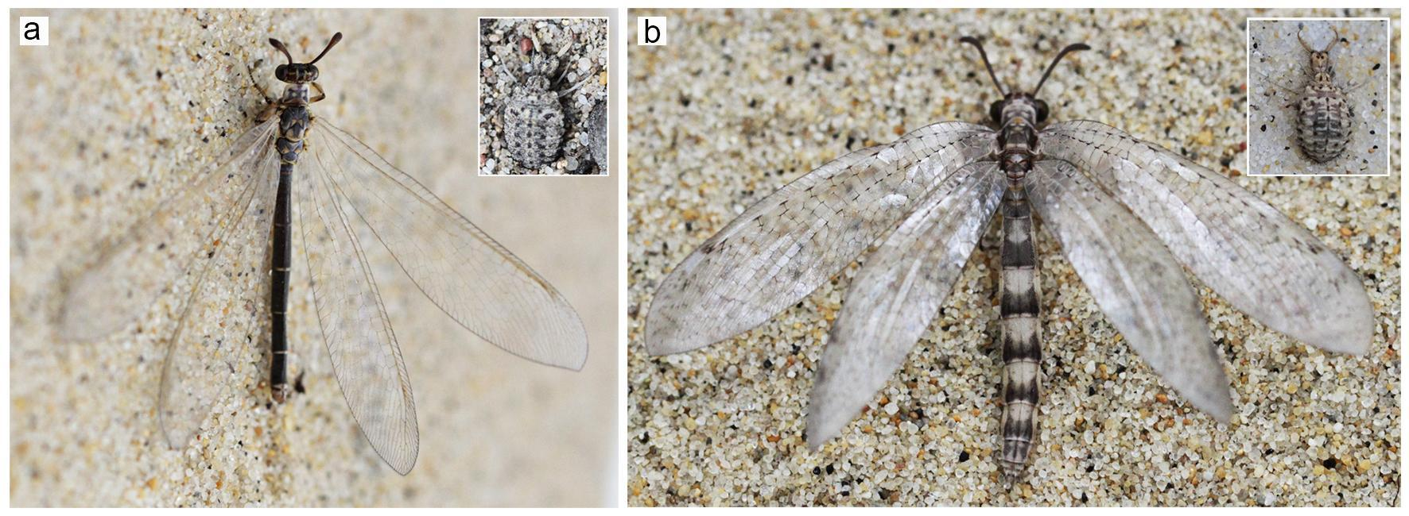

**Figure 1.** *Myrmeleon hyalinus* (a) and *Myrmeleon almohadarum* (b) in adult (imago) stage. Insets show the corresponding larval stages of each species. Photographs taken on sandy substrate in controlled laboratory conditions.

The primary objective of this study is to evaluate the impact of different temperature regimes, including both stable high temperatures and fluctuating conditions, on the development, survival, and morphological characteristics of two antlion species, *Myrmeleon almohadarum* and *Myrmeleon hyalinus*. Specifically, we aim to determine how stable and fluctuating thermal conditions influence the duration of larval development across different instars. We also assess mortality rates under varying temperatures, and examine the effects of temperature on key morphological parameters, including body mass, body length, forewing length, and the occurrence of morphological abnormalities. Furthermore, we investigate the relationship between temperature and larval feeding activity, as well as pit trap formation, to identify potential adaptive mechanisms that may enhance survival under elevated thermal conditions. By addressing these aspects, this study seeks to provide deeper insights into the physiological and behavioural responses of antlions to climate change and their potential capacity for thermal adaptation.

Based on previous research and the expected physiological responses of insects to thermal stress, we formulated the following hypotheses: **Hypothesis 1:** Increased temperature, particularly under stable 29 °C, 33 °C, and fluctuating 27 °C/39 °C conditions, will result in elevated larval mortality, with early instars being the most vulnerable (CITE relevant study). **Hypothesis 1:** Increased temperature, particularly under stable 29 °C, 33 °C, and fluctuating 27 °C/39 °C conditions, will result in elevated larval mortality, with early instars being the most vulnerable. **Hypothesis 2:** Exposure to higher temperatures will impose greater energetic demands on *Myrmeleon almohadarum* larvae, leading to accelerated development but without a significant reduction in adult body mass or overall size. **Hypothesis 3:** *Myrmeleon almohadarum* and *Myrmeleon hyalinus* will exhibit distinct responses to thermal stress, with *M. almohadarum* demonstrating higher thermal tolerance, as reflected by accelerated development and lower frequency of morphological abnormalities under high temperatures.**Hypothesis 4:** Elevated temperatures will increase the frequency of morphological abnormalities in adults, particularly structural deformities (e.g., wing malformations), but will not significantly affect overall body size or wing length.

By testing these hypotheses, this study aims to contribute to a broader understanding of species-specific thermal tolerance and the potential resilience of antlions to ongoing climate change.

### **Materials and methods**

*Study species*

This study focused on two species of antlions, *Myrmeleon hyalinus* and *Myrmeleon almohadarum*. Larvae of both species were collected in Doñana National Park—one of the key conservation areas of the Mediterranean region, characterized by landscape mosaics, including sand dunes and open arid habitats favorable for these specialized predators (Serediuk et al., unpublished data; Domingo et al., 2020; Pérez-Ramos et al., 2017). This region, located in southern Spain, is likely transitioning into a tropical-subtropical zone (F or H) (García et al., 2014) and is highly vulnerable to climate change. Predictions indicate that Doñana may experience significant local warming, increased frequency of extreme weather events (droughts, heatwaves), and a reduction in climatically similar areas, limiting species' migration opportunities.

*Myrmeleon hyalinus* is a widely distributed Mediterranean species found in Macaronesia, North Africa, the Middle East, and Central and South Asia (Monserrat & Acevedo, 2013; Monserrat, 2022). On the Iberian Peninsula and the Balearic Islands, this species is most common in coastal areas influenced by the Mediterranean climate. In Doñana National Park, *M. hyalinus* is one of the dominant *Myrmeleontidae* species, constructing cone-shaped pit traps and occupying various habitats, though, its highest population density has been recorded in sandy dunes with sparse shrub vegetation.

*Myrmeleon almohadarum* was described relatively recently, in 2016, based on specimens collected in Spain and North Africa, particularly in Tunisia (Ramos, 2017; Monserrat, 2022). Its known range includes the southern Iberian Peninsula, the Balearic Islands, and recently documented occurrences in Seville and Tarragona (Ramos, 2017; Monserrat, 2022). In North Africa, this species has been confirmed in Tunisia and is likely distributed along the northwestern Mediterranean coast of Africa, excluding desert regions. The larvae of *M. almohadarum* build typical conical pit traps in sandy dunes and along dirt roads near human settlements. Local populations can reach several hundred individuals in specific microhabitats. Developmental stages of the larvae were identified and classified according to the studies of Badano & Pantaleoni (2014) and Badano et al. (2016).

Larval specimens were collected from three different habitats in Doñana National Park, characterized by varying degrees of shading, soil structure, and vegetation cover:

* **Site 1 (36°59'59.34"N, 6°30'45.13"W):** Larvae were collected from sandy soil rich in organic material, including plant debris and litter. Nearby eucalyptus trees provided shade for most of the day, with poplars and shrubs approximately 50 meters away. The larvae’s pit traps were located about 1 meter from the edge of a dirt road, with some positioned directly on the road surface.
* **Site 2 (36°58'36.8"N, 6°29'36.2"W):** This area consisted of open sand dunes with scattered shrub vegetation, including *Corema album* and *Juniperus macrocarpa*, which were widely spaced apart. Isolated Mediterranean pines (*Pinus pinea*) were also present near the study site, partially influencing its microclimate.
* **Site 3 (36°59'23.9"N, 6°26'35.5"W):** Larvae constructed pit traps along a dirt road, no further than 1.5 meters from its edge. Some traps were found in shaded areas beneath Mediterranean shrubs such as *Rosmarinus officinalis*, *Halimium halimifolium*, and *Lavandula stoechas*, near *Pinus pinea*. Another group of traps was located in fully sun-exposed areas, receiving direct sunlight throughout the day.

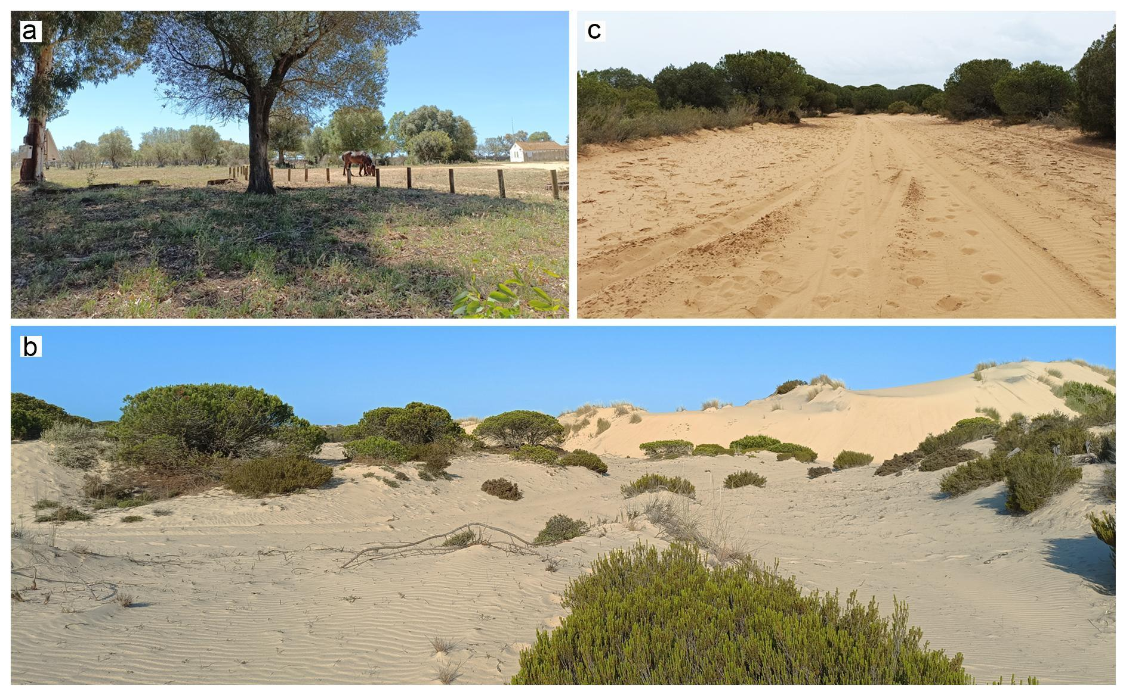**Figure 2.** Study sites in Doñana National Park.

(a) Site 1 – semi-shaded area with sandy soil and organic matter near eucalyptus trees.

(b) Site 2 – open sand dunes with sparse shrub vegetation.

(c) Site 3 – sandy roadside habitat with shaded and sun-exposed microhabitats.

Since different developmental stages of antlions may vary in behavioural traits and thermal tolerance (Alcalay et al., 2014), this study included larvae from the first, second, and third instars of both species. This approach allowed for the assessment of potential differences in thermal tolerance and behavioural responses across larval stages.

### **Experimental Conditions**

All experiments were conducted in climate-controlled chambers at the Animal Experimentation Unit (Unidad de Experimentación Animal, UEA) of the Doñana Biological Station (Spain). Larvae were maintained under a 16L:8D photoperiod and 65±3% relative humidity, with temperature conditions varying according to the specific experimental treatments.

In laboratory conditions, larval body length was measured using an electronic calliper with a precision of 0.01 mm, and body mass was recorded using an electronic balance with an accuracy of 0.001 g. Each larva was also classified by developmental stage. Larvae were individually housed in labelled plastic containers (15 cm in diameter, 20 cm in height) filled with 500 g of sieved sand collected from their respective field sites. Observations were conducted daily throughout the entire developmental period and after adult emergence.

At 12:00 each day, larval activity status was assessed and categorized as either "active" or "inactive." Larvae were considered active if they maintained functional, undisturbed pit traps and remained visible (i.e., their mandibles protruded from the bottom of the pit). For all active larvae, pit trap diameter was measured, and feeding activity was recorded based on whether prey was consumed in the last 24 hours. Regardless of activity status, each larva was provided with a fresh prey item daily. Inactive larvae were checked for signs of life.

Upon pupation, containers were covered with fine mesh to prevent adult escape after emergence. Following adult eclosion, individuals were sexed, examined for morphological abnormalities, measured for body length and forewing length using an electronic calliper, and weighed with an electronic balance.

### **Experimental Design**

#### **Experiment 1:** The first experiment lasted for 37 days and began on May 17, 2023. A total of 17 *Myrmeleon almohadarum* larvae and 12 *Myrmeleon hyalinus* larvae were collected from Sites 1 and 3. In the laboratory, species identification was confirmed, and all individuals were determined to be in the third larval instar. The larvae were maintained at a constant temperature of 25±1°C. Following a 24-hour acclimation period, they were fed daily by manually introducing ants (*Messor barbarus* Linnaeus, 1767) into the central pit of each individual.

#### **Experiment 2:** The second experiment lasted for 60 days and commenced on March 29, 2024. A total of 154 *Myrmeleon hyalinus* larvae (15 first instar, 21 second instar, and 115 third instar) were collected from Site 2, along with 25 *Myrmeleon almohadarum* larvae (5 first instar, 10 second instar, and 10 third instar) from Site 1. In the laboratory, species identification and developmental stage classification were confirmed. The larvae were first sorted by species and then by developmental stage before being placed into two climate chambers set at different temperature regimes: 29±1°C and 33±1°C. The photoperiod was set to 12 hours of light (9:00–19:00) and 12 hours of darkness (19:00–9:00). After a 24-hour acclimation period, the larvae were fed daily by introducing small *Tenebrio molitor* Linnaeus, 1758 larvae into the central pit of each individual.

#### **Experiment 3:** The third experiment lasted for 65 days and began on June 2, 2024. A total of 104 *Myrmeleon almohadarum* larvae (9 second instar and 95 third instar) were collected from Site 1. In the laboratory, species identification and developmental stage classification were confirmed**.** The larvae were evenly divided between the two temperature treatments: one group was maintained at a stable 27±1°C, while the other was subjected to a fluctuating temperature regime of 27±1°C at night (8 hours) and 33±1°C during the day (16 hours). The photoperiod and relative humidity were identical for both groups (16L:8D, 65±3%). Following a 24-hour acclimation period, the larvae were fed daily by introducing small *Tenebrio molitor* Linnaeus, 1758 larvae into their central pit traps.

**Data Analysis Methods**

### We explored how temperature treatments influenced *Myrmeleon* life history using model selection with Bayesian regressions implemented in the *brms* package of R version 4.4.2 (REFS). Specifically, we explored how temperature influenced the following response variables: i) larval mortality, ii) the initiation of pupation, iii) emergence to the imago stage, iv) imago morphology, v) larval pit trap dimensions and use, and vi) larval feeding behaviour. Bayesian regression models were run over four chains for 4000 iterations (including 2000 warm up iterations), and model convergence was assessed using (degree of chain mixing). Generally, we used weakly regularising priors, with normal priors (mean = 0, standard deviation = 0.5) for both general regression coefficient terms and global intercept terms. Specific priors used for each response variable are highlighted below, and for full model specifications see model code (REF). Predictions from the model with the best predictive performance were carried out using draws from the expected value of the posterior predictive distribution, which do not include residual error.

### Model selection was performed using leave-one-out cross validation implemented in the *LOO* package (REF), using the expected log-wise predictive density (), for which higher values indicate improved model predictive performance. We used model selection to explore the evidence for including the effects of temperature treatments, differences between species, and interactions between temperature and species on response variables. We used an initial base model, which included only temporal trend effects across the experiment (if appropriate), and an intercept-only random effect for individual to account for individual-level differences in life history. Candidate models then explored the addition of temperature and species-level differences. Specific model selection procedures can be found for each response variable below, and for full model selection specifications can be found in the model code (REF).

**Larval Mortality, Emergence, and Pupation**

We investigated the effect of temperature treatments on larval mortality, entering pupation, and emergence in the imago stage for *Myrmeleon* using a discrete-time hazard models. For each individual we constructed time-to-event data, where mortality, pupation, and emergence events were scored binomially across days of the experiment and individuals surviving (or individuals that did not pupate or emerge as adults) at the end of the experiment were right censored. Then, we modelled the hazard of mortality, pupation and emergence events using binomial models with the Bernoulli case (where the number trials for each observation was 1), and a complementary log-log link function, enabling the interpretation of model predictions in terms of daily hazards. The baseline hazard term was a smoothed effect of experiment day, implemented with cubic regression spline from the *mgcv* package, which had a basis dimension of 20. The base model for all discrete-time hazard models included the smoothed effect of experiment day and the intercept-only effect of individual ID. Then, we explored statistical support for an effect of temperature treatment and species by varying the smoothing term by temperature treatment, species, or an interaction between both terms. The resulting model selection was performed on four candidate models with varying effects of temperature treatment and species differences. All discrete-time hazard models included a truncated normal prior for the standard deviation of the individual ID random effect (mean = 0, standard deviation = 0.25, lower bound = 0), and a truncated normal prior for the basis weights of the smoothing term (mean = 0, standard deviation = 1, lower bound = 0).

**Imago morphology**

We investigated the effect of temperature treatments on imago morphology using multivariate linear regressions. The morphological traits of interest were body weight (g), body length (mm) and forewing length (mm) measured for individuals that reached the imago stage. We used multivariate models to account for strong covariance between morphological characteristics. We used Gaussian regressions with z-transformed (mean and standard-deviation centered) morphological traits. Multivariate models were constructed from constituent regressions for each of the morphological traits, which were combined including residual correlation between these response variables. The base models of all morphology model components included an effect of species, sex, and their a two-way interaction. Candidate models included the addition of a univariate temperature effect, a two-way interaction between temperature treatment and sex, and a two-way interaction between temperature treatment and species. All multivariate models included an additional Lewandowski-Kurowicka-Joe prior with a shape parameter of two.

**Pit traps and feeding behaviour**

Finally, we tested how temperature treatments influenced features of larval pit traps and feeding behaviour. Sex was not included in these models as traps were constructed before sex was determined. For the pit traps, we investigated the change in pit trap diameter (mm) across the experiment, and the number of days that individuals used pit traps. Pit trap diameter was modelling using a similar framework to larval mortality models, but with gaussian models for z-transformed pit diameter values. The base model for pit diameter included a smoothed effect for experiment day, an effect of species, and the intercept-only random effect for individual, and candidate models incorporated interactions with temperature treatment and the smoothing term for day. Additionally, we explored the predictive performance of an individual-level smoothing term, to test individual differences in pit diameter changes across the experiment, as well as a random slopes model that included a linear effect of temperature treatment that varied by individuals. The time with a pit trap was scored for each individuals as the number of days that the structure persisted across the experiment. We modelled the number of days with a pit trap as a Poisson process, with the base model including a univariate effect of species and the intercept-only random effect of individual. Then, we explored the incorporation of a linear effect of temperature treatment, as well as a two-way interaction with species. The final model selection took place for feeding behaviour, which was recorded for the subset of the individuals present in experiment 3. Here, the daily occurrence of feeding was scored binomially (fed or not fed), which we used to construct time-to-event data for each individual (censoring when individuals entered pupation or died). We used discrete-time survival analysis for feeding behaviour as above, but used a logit link function to reflect the odds of feeding on a given day. Feeding behaviour models did not include species effects, and instead tested for the support of a model including temperature treatment interacting with a smoothed effect of day.

### **Results**

### **Developmental Duration**

The total developmental duration (*from larval stage to imago emergence*) was substantially impacted by temperature treatment in *Myrmeleon*, with a more rapid onset of emergence at higher temperatures (Figure X; Table SX). In leave-one-out cross validation, we found strong statistical support for an interaction between the daily trend in emergence with temperature treatments ( compared to base model; Table SX). In the lowest temperature treatment of 27°C, the peak day of emergence was day 27.9 [24,35], which declined to day 18.6 [17,21] in the 33°C treatment (Figure Xa & Xc). Interestingly, the treatment emulating “natural” summer temperatures (27-39°C) had an intermediate peak day of emergence at 24.8 [22,28]. In addition to the timing of emergence, temperature treatments also exhibited differences in the average and peak probability of emergence (Figure Xb). Namely, the 29°C treatment had a substantially higher average and peak daily emergence probability than other treatments, with probabilities of 0.23 [0.13,0.37] and 0.048 [0.025,0.10] for peak and average probabilities, respectively. We did not find evidence for species-differences in emergence or its temporal trend across the experiment, with mean posterior predictions of emergence probabilities across the study of 0.031 [1.2 x 10-6, 0.175] and 0.033 [1.2 x 10-6, 0.184] for *Myrmeleon almohadarum* and *Myrmeleon hyalinus*, respectively. Together, these results suggest that increased temperatures increases the speed of the onset of emergence to the adult stage.

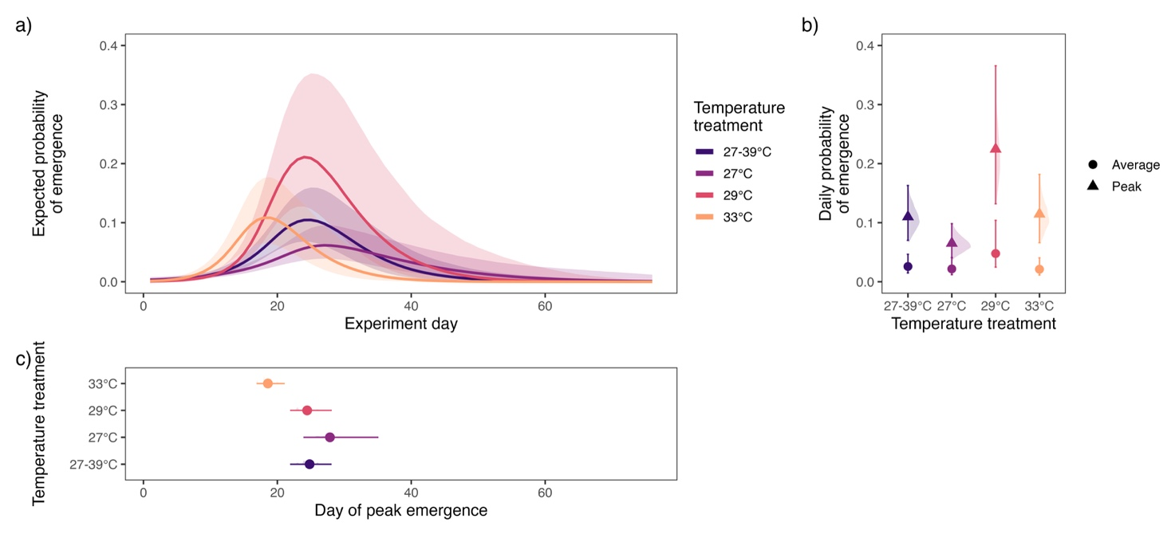



***Figure X. Emergence and temperature treatments for Myrmeleon.*** *a) temporal trends in emergence probability across temperature treatments (colours), captured with a daily smoothed effect for each treatment. Lines indicate the median of the posterior, with 95% confidence limits across the posterior. b) the average (points) and peak (triangle) probabilities of emergence across the experiment for each temperature treatment, with 95% confidence limits given by the error bars, and the shaded distribution of posterior values. Peak probabilities of emergence were calculated as the maximum emergence probability across draws of the posterior. c) the day of peak emergence for each temperature treatment, with 95% confidence limits and shaded distributions of posterior values.*

In contrast to emergence, the probability of entering pupation was not influenced by temperature treatments in *Myrmeleon*. Model selection indicated that the base model, distinguishing only average pupation probability differences between species had the highest predictive performance (; Table SX). Specifically, *Myrmeleon* *hyalinus* had a higher probability of pupation across the experiment, with a mean posterior pupation probability of 0.082 [0.016, 0.19] across experiment days, relative to 0.054 [0.011,0.125] in *Myrmeleon* *almohadarum*. The temporal trend in pupation indicated two peaks in pupation across the experiment across treatments: an initial peak at approximately 15-17 days, followed by a secondary peak at the end of the experiment at approximately 55-57 days (Figure X).

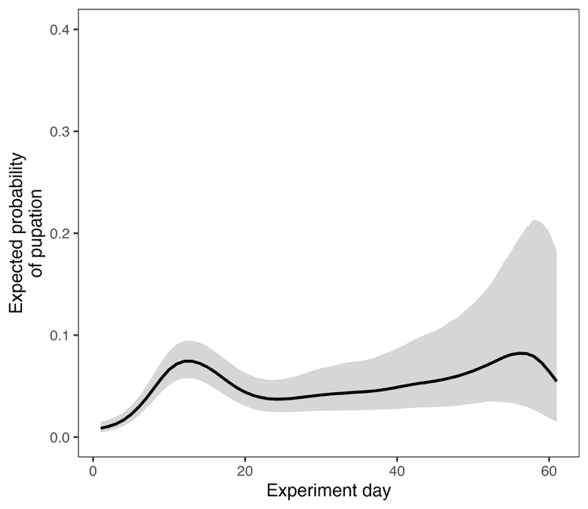

***Figure X. Temporal trends in pupation for Myrmeleon.*** *Line indicates posterior median predictions with 95% confidence limits across the posterior.*

### **Larval mortality**

We found partial support that larval mortality was influenced by temperature treatments, but stronger evidence for species-level differences in the temporal trend of larval mortality (Figure X; Table SX). Model selection indicated highest support for the species and temporal trend interaction model (; Table SX), but there was also support for a temperature by species interaction relative to the base model excluding temperature effects (; Table SX). For *Myrmeleon almohadarum*, the daily expected probability of mortality was approximately 0.5%, and there was no discernible temporal trend in mortality patterns, or substantial differences between temperature treatments (Figure X). In contrast, for *Myrmeleon hyalinus*, the daily mortality at the beginning of the experiment was substantially greater, lying between 1-1.5% before 20 days, and declining towards the end of the experiment. There was also some evidence that daily mortality was greater in the 33°C treatment relative to the 29°C treatment, peaking at day 20, which was supported relative to the base model, but there was still overlap in confidence intervals (Figure X).

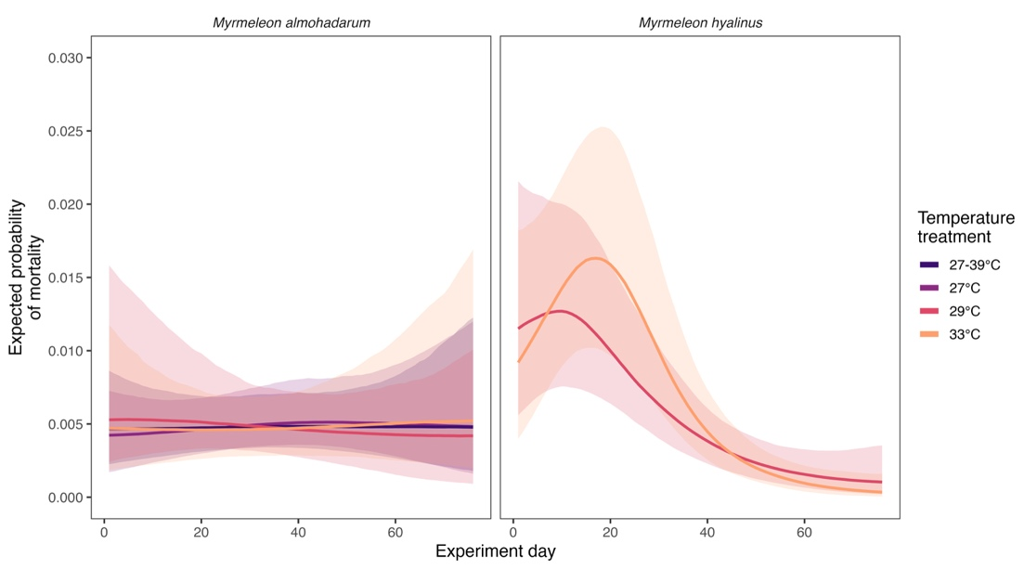

### ***Figure X. Temporal trends in mortality with respect to temperature for Myrmeleon*. *T****emporal trends in mortality probability across temperature treatments (colours), for M. almohadarum (left) and M. hyalinus (right) captured with a daily smoothed effect for each treatment within each species. Lines indicate the median of the posterior, with 95% confidence limits across the posterior.*

### **Adult morphology**

We did not find support for the hypothesis that temperature treatments influence adult morphology (Figure X; Table SX). In model selection, the base model, including only a two-way interaction between species and sex had the highest predictive performance (; Table SX).

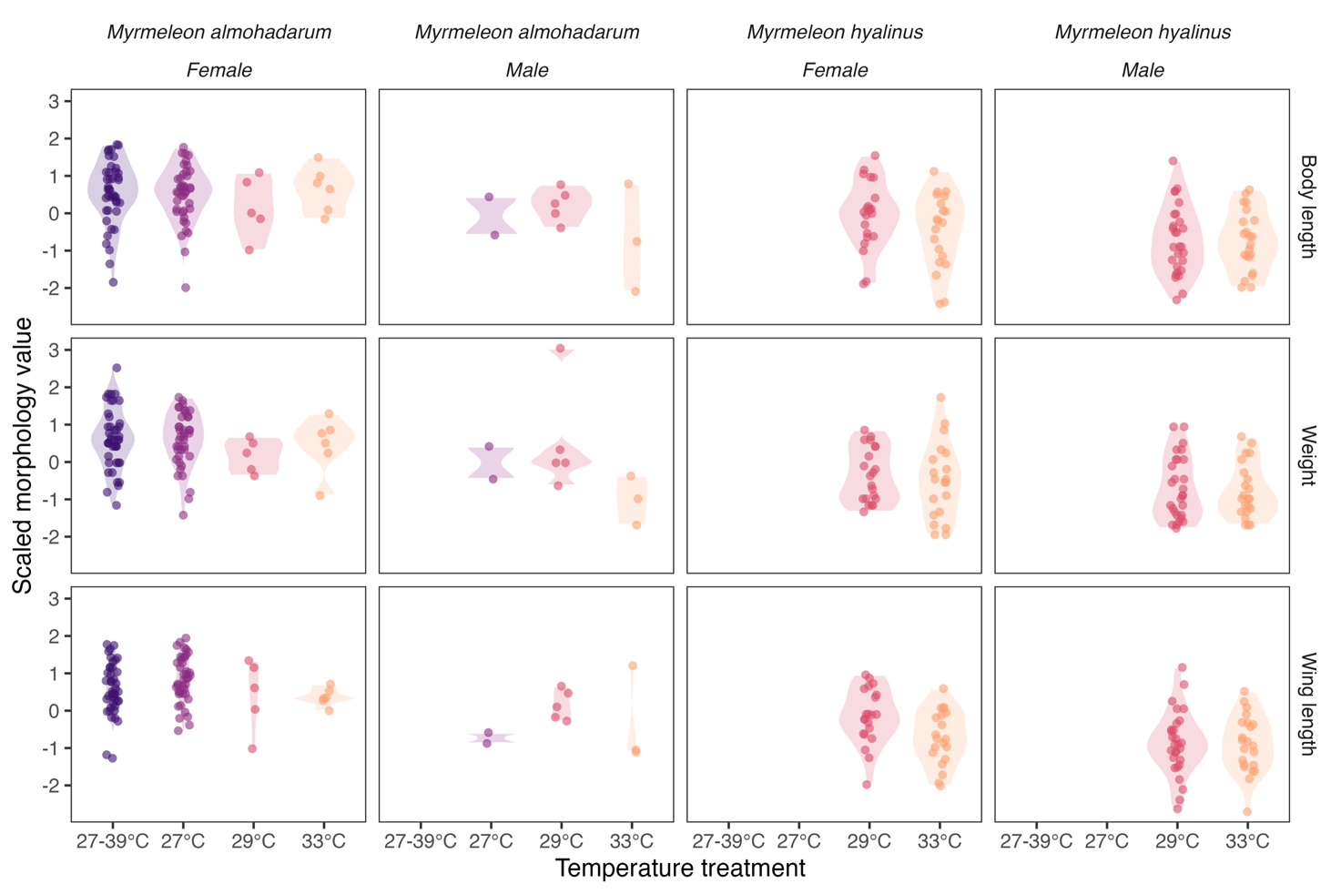

### ***Figure X. Adult morphology in Myrmeleon.*** *Raw observations for body length (top), weight (middle) and wing length (bottom) for Myrmeleon species, separated by sex and species (columns). Colours indicate temperature treatments. Points are z-transformed raw data values, and violins indicate the distribution of the data.*

### **Effect of Temperature on Adult Morphology Abnormalities**

The frequency of morphological abnormalities increased with rising temperatures, with the highest proportion of normally developed individuals recorded at 25°C (100%) and the lowest at 33°C. *Myrmeleon almohadarum* generally exhibited a lower frequency of abnormalities than *M. hyalinus*, particularly under high-temperature conditions. The fluctuating temperature regime (27–39°C) was associated with a higher proportion of normally developed individuals compared to constant high temperatures (33°C), suggesting a potential compensatory effect of nighttime cooling.

Although these trends suggest a negative impact of elevated temperatures on development, statistical analyses did not confirm significant differences between temperature treatments. Further research with larger sample sizes may be necessary to determine whether these trends reflect biologically meaningful patterns.

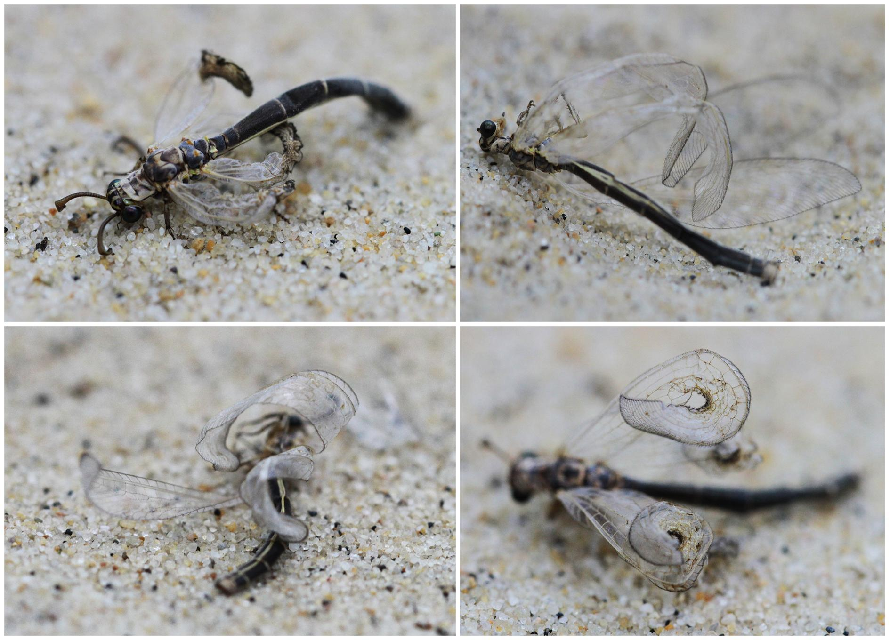

**Figure 3.** Morphological abnormalities in *Myrmeleon hyalinus* imagos. Deformed wings and exoskeletal malformations observed in individuals developed under high-temperature conditions.

**Larval pits and feeding behaviour**

Larval pit diameter and overall usage was affected by temperature treatments (Figure X; Table SX). For pit diameter, the model with the highest predictive performance was the model including an interaction between daily trend and temperature treatment ( relative to base model; Table SX). There was also some support for the model including random slopes for each individual, but the relative to the best model, and so we selected the simpler model with fewer parameters. Pit diameter generally decreased across the experiment, but at higher temperatures of 29°C and 33°C, the growth of pit traps was delayed until after day 10 in the experiment (Figure Xa). Furthermore, in the 27°C and 27-39°C treatments, there was a small increase in pit diameter towards the end of the experiment (Figure Xa), suggesting secondary usage of pit traps for larvae that did not pupate. For the number of days for which a pit trap was present, there was also evidence that temperature treatment had an impact on the number of days with a trap ( relative to the base model; Table SX). The two-way interaction between species and temperature treatment was only marginally supported through cross validation (. First, on average *M. hyalinus* spent two days fewer with a pit trap overall when compared to *M. almohadarum* (Figure Xb). For temperature treatments, the 27°C and 27-39°C treatments had fewer days with a pit trap, with a higher occurrence of pit traps at lower and higher temperatures (Figure Xb), which was consistent across species. For both species, the “natural” 27-39°C treatment had the fewest days with a pit trap, between 4 and 6 days.

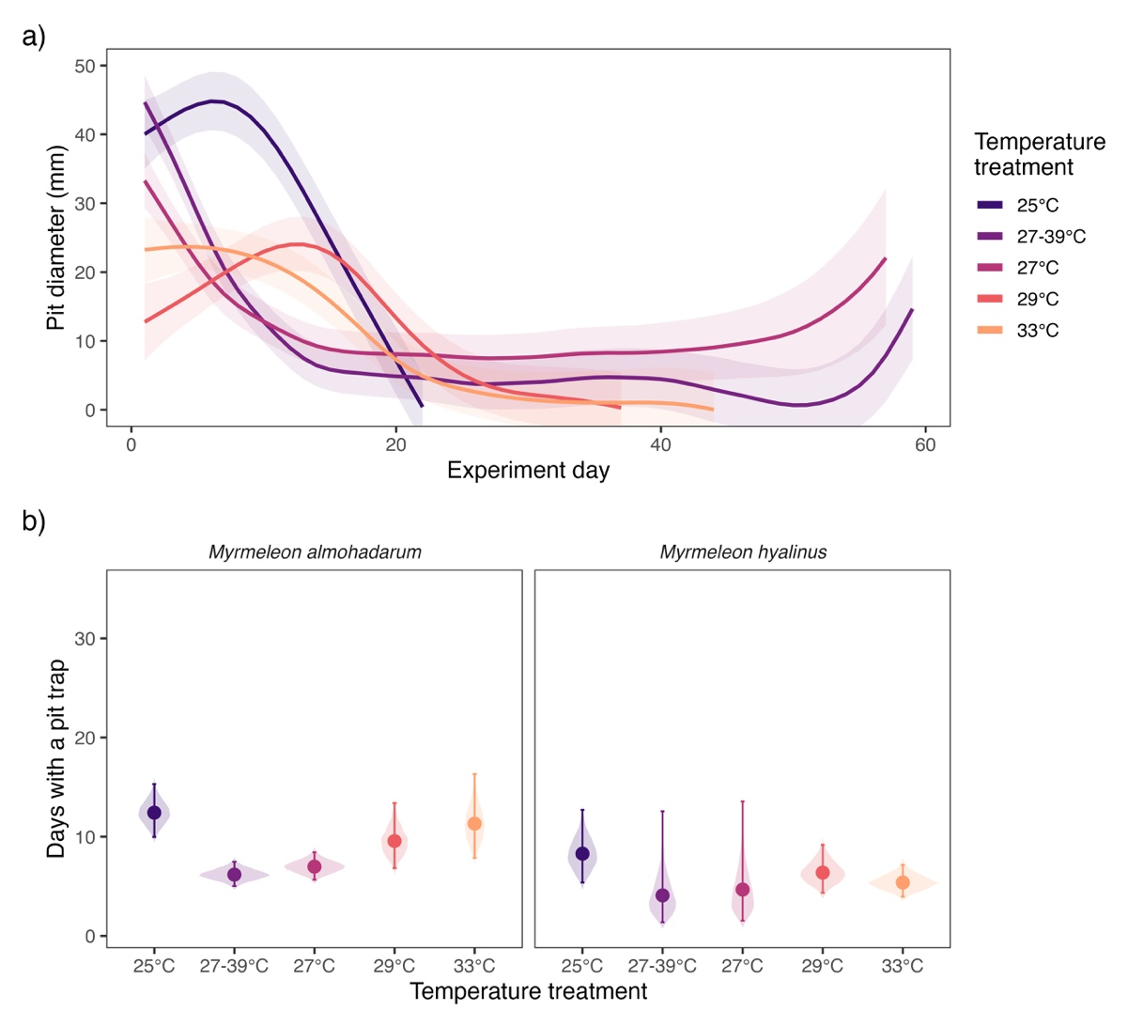

***Figure X. Pit trap characteristic and temperature treatments in Myrmeleon.*** *a) Daily trends in pit diameter (mm) across the experiment, separated by temperature treatments (colours). Lines indicate the median of the posterior, with 95% confidence limits across the posterior. b) posterior predictions for the number of days with a pit trap, separated by species and temperature treatments. Violin distributions indicate the posterior distribution, points give posterior median values, and error bars indicate 95% confidence limits.*

Finally, for the limited sample of temperature treatments for which data was available, we found support for an influence of temperature treatments on feeding behaviour (Figure X; Table SX). Feeding behaviour was substantially greater at the beginning of the experiment, with a high probability (> 80%) of feeding in the first five days. In the 27°C treatment, the probability of feeding remained higher than the 27-39°C treatment until day 18 of the experiment (Figure X). Furthermore, following pit diameter data, we found evidence for increased feeding behaviour towards the end of the experiment.

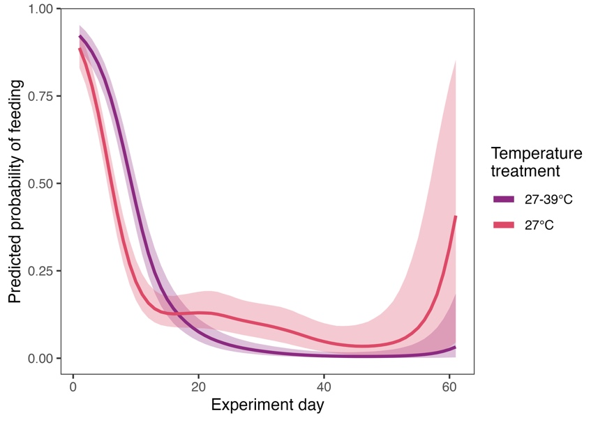

### ***Figure X. Temporal trends in feeding behaviour with respect to temperature for Myrmeleon*.** *Temporal trends in feeding behaviour probability across temperature treatments (colours), captured with a daily smoothed effect for each treatment. Lines indicate the median of the posterior, with 95% confidence limits across the posterior.*

## **Discussion**

Temperature is a critical environmental factor influencing insect development, survival, and physiological traits (Ashbrook et al., 2024; Bagni et al., 2024; Nervo et al., 2021; Miler et al., 2020; Huey et al., 2012; Rotkopf et al., 2012; Adamo & Lovett, 2011; Kingsolver & Huey, 2008). Our study explored the effects of stable high temperatures (29°C, 33°C) and fluctuating conditions (27°C at night, 39°C during the day) on the life-history parameters of *Myrmeleon almohadarum* and *Myrmeleon hyalinus* larvae. The results suggest that temperature may influence key developmental and morphological traits in these species, with potential implications for their thermal tolerance and ecological adaptations.

In line with our first hypothesis, elevated temperatures were associated with a trend of reduced larval survival, particularly at 33°C, where the lowest survival rates were recorded for both *M. almohadarum* (66.67%) and *M. hyalinus* (62.79%). Although these differences were not statistically significant, they align with previous studies demonstrating the detrimental effects of thermal stress on larval survival in ectotherms (Bagni et al., 2024; Nervo et al., 2021; Beever et al., 2017; Rotkopf et al., 2012). The reduction in survival at high temperatures is likely due to increased physiological stress, including disrupted water balance and elevated metabolic demands, as observed in other insects (Miler et al., 2020; Lucas, 1985).

Higher temperatures were also linked to accelerated development, supporting our second hypothesis. Larvae reared at 33°C developed faster than those at 25°C, with *M. almohadarum* completing larval development in an average of 14.5 ± 3.2 days—a ~30% reduction compared to 25°C—while *M. hyalinus* showed a similar pattern (12.8 ± 2.9 days). Interestingly, under the fluctuating temperature regime (27°C/39°C), development was also accelerated, but to a lesser extent than under stable high temperatures. These findings align with the general pattern observed in temperature-dependent development, where increased temperatures shorten development time in many insect species (Atkinson, 1994; Colinet et al., 2015; Karl et al., 2013; Kingsolver & Huey, 2008).

According to the temperature–size rule (Atkinson, 1994), increased temperatures typically lead to faster development but result in smaller adult sizes. However, our results showed that body mass and size were largely maintained across temperature treatments, while forewing length exhibited a slight reduction at higher temperatures. Although we observed a negative correlation between temperature and wing length, this relationship was not statistically significant, suggesting that morphological plasticity in response to thermal stress may be limited. The ability to maintain body size despite high temperatures may reflect an adaptive strategy that ensures flight performance and reproductive success in these species.

Interspecific differences in thermal tolerance were also apparent, partially supporting our third hypothesis. *M. almohadarum* showed relatively stable developmental patterns and a lower frequency of morphological abnormalities at high temperatures compared to *M. hyalinus*. This pattern may indicate greater adaptation to arid environments, as *M. almohadarum* is primarily distributed in southern Spain and North Africa, where temperatures are generally higher. However, further studies are needed to confirm whether these differences are statistically significant and to better understand the underlying physiological mechanisms.

Larval behavior also varied across temperature regimes. At 25°C, *M. almohadarum* and *M. hyalinus* constructed pits of moderate sizes (40–50 mm and 35–50 mm, respectively), while at 33°C, pit size and activity duration declined. Under the fluctuating temperature regime (27–39°C), *M. almohadarum* showed slightly greater resilience, maintaining pit sizes comparable to those observed at 27°C. These trends are consistent with previous studies reporting reductions in pit size and feeding activity under thermal stress (Rotkopf et al., 2012; Scharf & Ovadia, 2006; Lucas, 1985).

Feeding behavior exhibited notable variation between stable (27°C) and fluctuating (27–39°C) conditions in *M. almohadarum*. While larvae at 27°C maintained relatively stable feeding activity, those exposed to temperature fluctuations demonstrated more irregular feeding patterns, frequently experiencing extended periods of fasting. This irregularity may suggest a stress response or an energy conservation strategy to cope with unpredictable environmental conditions. Similar feeding adjustments have been observed in other ectotherms subjected to thermal fluctuations (Paaijmans et al., 2013; Lehmann et al., 2017).

Our fourth hypothesis predicted that high temperatures would lead to morphological abnormalities, particularly wing deformities. We observed an increase in the frequency of abnormalities at 33°C, where the proportion of normally developed individuals declined to 57.14% in *M. hyalinus* and 62.79% in *M. almohadarum*, compared to 100% at 25°C. Although these trends were apparent, the differences were not statistically significant, suggesting that while thermal stress may contribute to developmental instability, other factors could also be at play.

Interestingly, the fluctuating temperature regime (27–39°C) was associated with a lower frequency of morphological abnormalities (93.33% of individuals developed normally), suggesting that nighttime cooling may mitigate some of the negative effects of high daytime temperatures. This aligns with findings in other insect species, where thermal stress-induced abnormalities were reduced when individuals experienced periodic temperature relief (Thompson et al., 2017; Seiter & Kingsolver, 2013). The potential for nighttime cooling to buffer against extreme daytime temperatures warrants further investigation, as it may have important implications for predicting species responses to climate change.

The differential tolerance to thermal stress observed between the two antlion species may have significant ecological implications. *M. almohadarum* demonstrated greater resilience to extreme temperatures, which could provide a competitive advantage in arid environments and facilitate range expansion under global warming scenarios. In contrast, *M. hyalinus*, which exhibited higher sensitivity to thermal stress, may be more vulnerable to climate change, potentially experiencing range contractions in regions with increasing heatwaves. These findings highlight the importance of considering species-specific responses when predicting the impacts of climate change on insect populations.

Phenotypic plasticity in ectotherms may not always be sufficient to ensure long-term adaptation to rising temperatures (Gunderson & Stillman, 2015). Thus, future research should not only examine short-term physiological adaptations but also explore potential long-term shifts in species distribution and viability. Understanding the role of natural diurnal temperature fluctuations in mitigating thermal stress will be particularly important in assessing species resilience to climate change (Kellermann & Heerwaarden, 2019; Johansson et al., 2020; Suggitt et al., 2018).

### **Acknowledgements**

This work was funded by the Consejo Superior de Investigaciones Científicas (CSIC) through the grant UCRAN20052. MP was additionally supported by the grant RYC2021-033192-I from MCIN/AEI/10.13039/501100011033 and by the “European Union NextGenerationEU/PRTR”.

### **References**

1. Ábrahám, L. (2003). Temperature tolerance and predatory strategy of pit-building ant-lion larvae (Neuroptera: Myrmeleontidae). Acta Phytopathologica et Entomologica Hungarica, 38(1–2), 167–179. https://doi.org/10.1556/APhyt.38.2003.1-2.19
2. Adamo, S. A., & Lovett, M. M. E. (2011). Some like it hot: The effects of climate change on reproduction, immune function, and disease resistance in the cricket Gryllus texensis. The Journal of Experimental Biology, 214(12), 1997–2004. https://doi.org/10.1242/jeb.056531
3. Alcalay Y, Barkae ED, Ovadia O, Scharf I. 2014. Consequences of the instar stage for behavior in a pit-building antlion. Behav Processes. 103:105–111.
4. Andrew NR, Hart RA, Jung MP, Hemmings Z, Terblanche JS. 2013. Can temperate insects take the heat? A case study of the physiological and behavioural responses in a common ant, Iridomyrmex purpureus (Formicidae), with potential climate change. J Insect Physiol. 59:870–880.
5. Ashbrook, A. R., Feder, J. L., Bennett, G. W., Ginzel, M. D., & Gondhalekar, A. D. (2024). Lethal and sublethal heat-exposure of bed bugs (Cimex lectularius L.) causes alarm pheromone emission and elicits a movement response in nearby recipients. Scientific Reports, 14, 8555
6. Ashbrook, O. R., Zambon, I., Dierickx, E. G., et al. (2024). Physiological responses of insects to temperature extremes: Mechanisms, adaptation, and evolutionary trade-offs. Journal of Experimental Biology, 227(3), jeb245376. https://doi.org/10.1242/jeb.245376
7. Atkinson, D. (1994). Temperature and organism size: A biological law for ectotherms? Advances in Ecological Research, 25, 1–58. https://doi.org/10.1016/S0065-2504(08)60212-3
8. Ayres, M. P., & Scriber, J. M. (1994). Local adaptation to regional climates in Papilio canadensis (Lepidoptera: Papilionidae). Ecological Monographs, 64(4), 465-482. https://doi.org/10.2307/2937146
9. Badano, D., and R. A. Pantaleoni. 2014. The Larvae of European Myrmeleontidae (Neuroptera). Zootaxa 3762(1): 1. https://doi.org/10.11646/zootaxa.3762.1.1.
10. Badano, D., F. Acevedo, R. A. Pantaleoni, and V. J. Monserrat. 2016. Myrmeleon almohadarum sp. nov., from Spain and North Africa, with Description of the Larva (Neuroptera Myrmeleontidae). Zootaxa 4196(2): 210. https://doi.org/10.11646/zootaxa.4196.2.2.
11. Bagni, T., Siaussat, D., Maria, A., Fuentes, A., Couzi, P., & Massot, M. (2024). Fitness under high temperatures is overestimated when daily thermal fluctuation is ignored. Journal of Thermal Biology, 119, 103806. https://doi.org/10.1016/j.jtherbio.2024.103806
12. Baranov, V., Jourdan, J., Pilotto, F., Wagner, R., & Haase, P. (2020). Complex and nonlinear climate-driven changes in freshwater insect communities over 42 years. Conservation Biology, 34, 1241–1251. https://doi.org/10.1111/cobi.13495
13. Beever, E. A., Hall, L. E., Varner, J., Loosen, A. E., Dunham, J. B., Gahl, M. K., Smith, F. A., & Lawler, J. J. (2017). Behavioral flexibility as a mechanism for coping with climate change. Frontiers in Ecology and the Environment, 15(6), 299–308. https://doi.org/10.1002/fee.1502
14. Bennett S, Duarte CM, Marbà N, Wernberg T. 2019. Integrating withinspecies variation in thermal physiology into climate change ecology. Philos Trans R Soc Lond B Biol Sci. 374:20180550.
15. Boggs, C. L. 2016. “The Fingerprints of Global Climate Change on Insect Populations.” Current Opinion in Insect Science 17: 69–73.
16. Bowler, K., & Terblanche, J. S. (2008). Insect thermal tolerance: What is the role of ontogeny, ageing and senescence? Biological Reviews, 83, 339–355.
17. Buchholz R, Banusiewicz JD, Burgess S, Crocker-Buta S, Eveland L, Fuller L. 2019. Behavioural research priorities for the study of animal response to climate change. Anim Behav. 150:127–137.
18. Cain, M. L. (1987). Prey capture behavior and diel movement of Brachynemurus (Neuroptera: Myrmeleontidae) antlion larvae in South Central Florida. Florida Entomologist, 70(3), 397–400. https://doi.org/10.2307/3495074
19. Chapman SC, Watkins NW, Stainforth DA. 2019. Warming trends in summer heatwaves. Geophys Res Lett. 46:1634–1640.
20. Clusella-Trullas, S., Blackburn, T. M., & Chown, S. L. (2011). Climatic predictors of temperature performance curve parameters in ectotherms imply complex responses to climate change. The American Naturalist, 177(6), 738–751. https://doi.org/10.1086/660021
21. Colinet, H., Sinclair, B. J., Vernon, P., & Renault, D. (2015). Insects in fluctuating thermal environments. Annual Review of Entomology, 60(1), 123–140. https://doi.org/10.1146/annurev-ento-010814-021017
22. Coumou D, Rahmstorf S. 2012. A decade of weather extremes. Nat Clim Change. 2:491–496.
23. Domingo, M. S., Martín-Perea, D. M., Badgley, C., Cantero, E., López-Guerrero, P., Oliver, A., & Negro,J. J. 2020. Taphonomic information from the modern vertebrate death assemblage of Doñana NationalPark, Spain. PLOS ONE, 15(11), e0242082.
24. Easterling, D. R., Meehl, G. A., Parmesan, C., Changnon, S. A., Karl, T. R., & Mearns, L. O. (2000). Climate extremes: observations, modeling, and impacts. Science (New York, N.Y.), 289(5487), 2068–2074. https://doi.org/10.1126/science.289.5487.2068
25. Feder, M. E., Blair, N. T., & Figueras, H. (1997). Natural thermal stress and heat-shock protein expression in drosophila larvae and pupae. Functional Ecology, 11, 90–100.
26. García-Robledo, C., E. K. Kuprewicz, C. L. Staines, T. L. Erwin, and W. J. Kress. 2016. “Limited Tolerance by Insects to High Temperatures across Tropical Elevational Gradients and the Implications of Global Warming for Extinction.” Proceedings of the National Academy of Sciences 113: 680–5.
27. Green, G. W. (1955). Temperature relations of ant-lion larvae (Neuroptera: Myrmeleontidae). The Canadian Entomologist, 87(10), 441–459. https://doi.org/10.4039/Ent87441-10
28. Gunderson, A. R., & Stillman, J. H. (2015). Plasticity in thermal tolerance has limited potential to buffer ectotherms from global warming. Proceedings of the Royal Society B: Biological Sciences, 282(1808), 20150401. https://doi.org/10.1098/rspb.2015.0401
29. Halsch, C. A., A. M. Shapiro, J. A. Fordyce, C. C. Nice, J. H. Thorne, D. P. Waetjen, and M. L. Forister. 2021. “Insects and Recent Climate Change.” Proceedings of the National Academy of Sciences 118: e2002543117.
30. Harrison, J. F., H. A. Woods, and S. P. Roberts. 2012. Ecological and Environmental Physiology of Insects. Oxford: Oxford University Press.
31. Harvey, J. A., Heinen, R., Gols, R., Thakur, M. P., Bezemer, T. M., & Biere, A. (2022). Scientists’ warning on climate change and insects. Ecological Monographs, 92(1), e1490. https://doi.org/10.1002/ecm.1490
32. Harvey, J. A., R. Heinen, I. Armbrecht, Y. Basset, J. H. Baxter-Gilbert, T. M. Bezemer, M. Böhm, R. Bommarco, P. A. Borges, and P. Cardoso. 2020. “International Scientists Formulate a Roadmap for Insect Conservation and Recovery.” Nature Ecology & Evolution 4: 174–6.
33. Heinrich, B., & Heinrich, M. J. E. (1984). The pit-trapping foraging strategy of the ant lion, Myrmeleon immaculatus DeGeer (Neuroptera: Myrmeleontidae). Behavioral Ecology and Sociobiology, 14(2), 151–160. https://doi.org/10.1007/BF00299497
34. Huey, R. B., Kearney, M. R., Krockenberger, A., Holtum, J. A. M., Jess, M., & Williams, S. E. (2012). Predicting organismal vulnerability to climate warming: roles of behaviour, physiology and adaptation. Philosophical Transactions of the Royal Society B: Biological Sciences, 367(1605), 1665–1679. https://doi.org/10.1098/rstb.2012.0005
35. Iltis, C., Louâpre, P., Pecharová, K., Thiéry, D., Zito, S., Bois, B., & Moreau, J. (2019). Are life-history traits equally affected by global warming? A case study combining a multi-trait approach with fine-grain climate modeling. Journal of Insect Physiology, 117, 103916.
36. IPCC, 2013: Climate Change 2013: The Physical Science Basis. Contribution of Working Group I to the Fifth Assessment Report of the Intergovernmental Panel on Climate Change [Stocker, T.F., D. Qin, G.-K. Plattner, M. Tignor, S.K. Allen, J. Boschung, A. Nauels, Y. Xia, V. Bex and P.M. Midgley (eds.)]. Cambridge University Press, Cambridge, United Kingdom and New York, NY, USA, 1535 pp.
37. Janzen, D. H., & Hallwachs, W. (2019). Perspective: Where might be many tropical insects? Biological Conservation, 233, 102–108. https://doi.org/10.1016/j.biocon.2019.02.028
38. Jiguet, F., Brotons, L., & Devictor, V. (2011). Community responses to extreme climatic conditions. Current Zoology, 57(3), 406–413.
39. Johansson, F., Orizaola, G., & Nilsson-Örtman, V. (2020). Temperate insects with narrow seasonal activity periods can be as vulnerable to climate change as tropical insect species. Scientific Reports, 10(1), 8822. https://doi.org/10.1038/s41598-020-65608-7
40. Karl, I., Stoks, R., Bauerfeind, S. S., Dierks, A., Franke, K., & Fischer, K. (2013). No trade-off between growth rate and temperature stress resistance in four insect species. PLoS ONE, 8(4), e62434. https://doi.org/10.1371/journal.pone.0062434
41. Kellermann, V., & van Heerwaarden, B. (2019). Terrestrial insects and climate change: Adaptive responses in key traits. Physiological Entomology, 44(2), 99–115. https://doi.org/10.1111/phen.12282
42. Kingsolver, J. G., & Huey, R. B. (2008). Size, temperature, and fitness: three rules. Evolutionary Ecology Research, 10, 251–268.
43. Kingsolver, J. G., Woods, H. A., Buckley, L. B., Potter, K. A., MacLean, H. J., & Higgins, J. K. (2011). Complex life cycles and the responses of insects to climate change. Integrative and Comparative Biology, 51(5), 719–732. https://doi.org/10.1093/icb/icr015
44. Klein, B. G. (1982). Pit construction by antlion larvae: Influences of soil illumination and soil temperature. Journal of the New York Entomological Society, 90(1), 26–30. https://www.biodiversitylibrary.org/item/206089
45. Lehmann, P., Van der Bijl, W., Nylin, S., Wheat, C. W., & Gotthard, K. (2017). Timing of diapause termination in relation to variation in winter climate. Physiological Entomology. https://doi.org/10.1111/phen.12188
46. Lucas, J. R. (1985). Metabolic rates and pit-construction costs of two antlion species. Journal of Animal Ecology, 54(1), 295–309. https://www.jstor.org/stable/4639
47. Ma, C.-S., Ma, G., & Pincebourde, S. (2021). Survive a warming climate: Insect responses to extreme high temperatures. Annual Review of Entomology, 66(1), 163–184. https://doi.org/10.1146/annurev-ento-041520-074454
48. Macgregor, C. J., Thomas, C. D., Roy, D. B., Beaumont, M. A., Bell, J. R., Brereton, T., Bridle, J. R., Dytham, C., Fox, R., Gotthard, K., Hoffmann, A. A., Martin, G., Middlebrook, I., Nylin, S., Platts, P. J., Rasteiro, R., Saccheri, I. J., Villoutreix, R., Wheat, C. W., & Hill, J. K. (2019). Climate-induced phenology shifts linked to range expansions in species with multiple reproductive cycles per year. Nature Communications, 10(1), 4455. https://doi.org/10.1038/s41467-019-12479-w
49. Marsh, A. C. (1987). Thermal responses and temperature tolerance of a desert ant-lion larva. Journal of Thermal Biology, 12(4), 295–300. https://doi.org/10.1016/0306-4565(87)90031-3
50. Martay, B., Brewer, M. J., Elston, D. A., Bell, J. R., Harrington, R., Brereton, T. M., Barlow, K. E., Botham, M. S., & Pearce-Higgins, J. W. (2017). Impacts of climate change on national biodiversity population trends. Ecography, 40, 1139–1151. https://doi.org/10.1111/ecog.02661
51. McKechnie AE, Wolf BO. 2010. Climate change increases the likelihood of catastrophic avian mortality events during extreme heat waves. Biol Lett. 6:253–256.
52. Meehl, G. A., & Tebaldi, C. (2004). More intense, more frequent, and longer lasting heat waves in the 21st century. Science (New York, N.Y.), 305(5686), 994–997. https://doi.org/10.1126/science.1098704
53. Monserrat, V. J. 2022. Los Neuropterida de la Península Ibérica y Baleares. Zaragoza: Sociedad Entomológica Aragonesa (S.E.A.).
54. Monserrat, V. J., and F. Acevedo. 2013. Los Mirmeleónidos (Hormigas-León) de la Península Ibérica e Islas Baleares (Insecta, Neuropterida, Neuroptera, Myrmeleontidae). Graellsia 69(2): 283–321. https://doi.org/10.3989/graellsia.2013.v69.098.
55. Morey, A. C., Venette, R. C., & Hutchison, W. D. (2018). Sublethal effects of subzero temperatures on the light brown apple moth, Epiphyas postvittana: Fitness costs in response to partial freezing. Insect Science, 26, 311–321
56. Nervo, B., Roggero, A., Isaia, M., Chamberlain, D., Rolando, A., & Palestrini, C. (2021). Integrating thermal tolerance, water balance and morphology: An experimental study on dung beetles. Journal of Thermal Biology, 101, 103093. https://doi.org/10.1016/j.jtherbio.2021.103093
57. Nice, C. C., Forister, M. L., Harrison, J. G., Gompert, Z., Fordyce, J. A., Thorne, J. H., Waetjen, D. P., & Shapiro, A. M. (2019). Extreme heterogeneity of population response to climatic variation and the limits of prediction. Global Change Biology, 25(7), 2127–2136. https://doi.org/10.1111/gcb.14593
58. Paaijmans, K. P., Heinig, R. L., Selig, R. A., Blanford, J. I., Blanford, S., Murdock, C. C., & Thomas, M. B. (2013). Temperature variation makes ectotherms more sensitive to climate change. Global Change Biology, 19(8), 2373–2380. https://doi.org/10.1111/gcb.12240
59. PCC. 2021. “ClimateChange2021:ThePhysicalScienceBasis.” In Contribution of Working Group I to the Sixth Assessment Report of the Intergovernmental Panel on Climate Change, edited by V. Masson-Delmotte, P. Zhai, A. Pirani, S. L. Connors, C. Péan, S. Berger, N. Caud, Y. Chen, L. Goldfarb, M. I. Gomis, M. Huang, K. Leitzell, E. Lonnoy, J. B. R. Matthews, T. K. Maycock, T. Waterfield, O. Yelekçi, R. Yu, and B. Zhou. Cambridge and New York, NY: Cambridge University Press.
60. Pecl, G. T., Araújo, M. B., Bell, J. D., et al. (2017). Biodiversity redistribution under climate change: Impacts on ecosystems and human well-being. Science, 355(6332), eaai9214. https://doi.org/10.1126/science.aai9214
61. Pérez-Ramos, I. M., R. Díaz-Delgado, E. G. de la Riva, R. Villar, F. Lloret, and T. Marañón. 2017. Climate Variability and Community Stability in Mediterranean Shrublands: The Role of FunctionalDiversity and Soil Environment. Journal of Ecology 105(5): 1335–1346.https://doi.org/10.1111/1365-2745.12747.
62. Perkins-Kirkpatrick SE, Gibson PB. 2017. Changes in regional heatwave characteristics as a function of increasing global temperature. Sci Rep. 7:12256.
63. Ramos, F. A. 2017. Avances en el Conocimiento de la Familia Myrmeleontidae (Insecta, Neuroptera) de la Península Ibérica y Baleares: Estadios Larvarios, Filogenia y Modelos de Distribución. Doctoral dissertation, Universidad Complutense de Madrid.
64. Raquel A. Garcia et al., Multiple Dimensions of Climate Change and Their Implications for Biodiversity. Science344, 1247579(2014). DOI:10.1126/science.1247579
65. Renner, S. S., & Zohner, C. M. (2018). Climate change and phenological mismatch in trophic interactions among plants, insects, and vertebrates. Annual Review of Ecology, Evolution, and Systematics, 49, 165–182. https://doi.org/10.1146/annurev-ecolsys-110617-062535
66. Rotkopf, R., Barkae, E. D., Bar-Hanin, E., Alcalay, Y., & Ovadia, O. (2012). Multi-Axis Niche Examination of Ecological Specialization: Responses to Heat, Desiccation and Starvation Stress in Two Species of Pit-Building Antlions. PLoS ONE, 7(11), e50884.
67. Scharf, I., & Ovadia, O. (2006). Factors influencing site abandonment and site selection in a sit-and-wait predator: A review of pit-building antlion larvae. Journal of Insect Behavior, 19(2), 197–218. https://doi.org/10.1007/s10905-006-9017-4
68. Scharf, I., Filin, I., Golan, M., Buchshtav, M., Subach, A., & Ovadia, O. (2008). A comparison between desert and Mediterranean antlion populations: Differences in life history and morphology. Journal of Evolutionary Biology, 21(1), 162–172. https://doi.org/10.1111/j.1420-9101.2007.01453.x
69. Schmitz OJ, Rosenblatt AE, Smylie M. 2016. Temperature dependence of predation stress and the nutritional ecology of a generalist herbivore. Ecology. 97:3119–3130.
70. Seiter, S., & Kingsolver, J. G. (2013). Environmental determinants of population divergence in life-history traits for an invasive species: climate, seasonality and natural enemies. Journal of Evolutionary Biology, 26
71. Serediuk, H., Jackson, J., Evers, S. M., & Paniw, M. (2024). Comparative life-history responses of lacewings to changes in temperature. Ecology and Evolution, 14, e70000. https://doi.org/10.1002/ece3.70000
72. Sinclair, B. J., & Marshall, K. E. (2018). The many roles of fats in overwintering insects. Journal of Experimental Biology, 221, jeb161836
73. Speights, C. J., Harmon, J. P., & Barton, B. T. (2017). Contrasting the potential effects of daytime versus nighttime warming on insects. Current Opinion in Insect Science, 23, 1–6.
74. Stork, N. E. 2018. “How Many Species of Insects and Other Terrestrial Arthropods Are There on Earth?” Annual Review of Entomology 63: 31–45.
75. Suggitt, A. J., Wilson, R. J., Isaac, N. J. B., Beale, C. M., Auffret, A. G., August, T., Bennie, J. J., Crick, H. Q. P., Duffield, S., Fox, R., Hopkins, J. J., Macgregor, N. A., Morecroft, M. D., & Maclean, I. M. D. (2018). Extinction risk from climate change is reduced by microclimatic buffering. Nature Climate Change, 8, 713–717. https://doi.org/10.1038/s41558-018-0231-9
76. Thompson, L. M., Faske, T. M., Banahene, N., Grim, D., Agosta, S. J., Parry, D., Tobin, P. C., Johnson, D. M., & Grayson, K. L. (2017). Variation in growth and developmental responses to supraoptimal temperatures near latitudinal range limits of gypsy moth (Lymantria dispar (L.)), an expanding invasive species: Geographic variation in heat tolerance. Physiological Entomology. https://doi.org/10.1111/phen.12190
77. Tuomainen U, Candolin U. 2011. Behavioural responses to human-induced environmental change. Biol Rev Camb Philos Soc. 86:640–657.
78. Ummenhofer, C. C., & Meehl, G. A. (2017). Extreme weather and climate events with ecological relevance: A review. Philosophical Transactions of the Royal Society B: Biological Sciences, 372(20160135). https://doi.org/10.1098/rstb.2016.0135
79. van Zyl, A., van der Linde, T. C. De K., & Grimbeek, R. J. (1997). Metabolic rates of pitbuilding and non-pitbuilding antlion larvae (Neuroptera: Myrmeleontidae) from southern Africa. Journal of Arid Environments, 37(2), 355–365. https://doi.org/10.1006/jaev.1997.0270
80. Vande Velde, L., & Van Dyck, H. (2013). Lipid economy, flight activity and reproductive behaviour in the speckled wood butterfly: On the energetic cost of territory holding. Oikos, 122(4), 555–562. https://doi.org/10.1111/j.1600-0706.2012.20747.x
81. Voigt, W., Perner, J., Davis, A. J., Eggers, T., Schumacher, J., Bährmann, R., Fabian, B., Heinrich, W., Köhler, G., Lichter, D., Marstaller, R., & Sander, F. W. (2003). Trophic levels are differentially sensitive to climate. Ecology, 84(9), 2444–2453. https://doi.org/10.1890/02-0266
82. Wagner, D. L. (2020). Insect declines in the Anthropocene. Annual Review of Entomology, 65, 457–480. https://doi.org/10.1146/annurev-ento-011019-025151
83. White, S. A., & Dillon, M. E. (2023). Climate warming and bumble bee declines: The need to consider sub-lethal heat, carry-over effects, and colony compensation. Frontiers in Physiology, 14, 1251235. https://doi.org/10.3389/fphys.2023.1251235
84. Youthed, G. J., & Moran, V. C. (1969). Pit construction by myrmeleontid larvae. Journal of Insect Physiology, 15(5), 867–875. https://doi.org/10.1016/0022-1910(69)90127-9

Previous studies have demonstrated temperature-dependent changes in antlion activity and their generally high thermal tolerance. For example, it has been found that they burrow deeper into the sand to avoid heat, leading to reduced prey capture efficiency at temperatures above 35 °C (Green, 1955), and they completely cease pit-building at temperatures exceeding 42 °C (Youthed & Moran, 1969). One of the earliest detailed studies on antlion thermoregulation was conducted by Marsh (1987), who examined the thermal responses and temperature tolerance of *Cueta trivirgata* larvae. It was found that these insects could withstand temperatures up to 53.4 °C, with their activity being strongly dependent on daily temperature fluctuations. Larger pits provided protection from overheating during the day and maintained a stable thermal environment at night, facilitating more effective hunting of thermophilic ants (*Ocymyrmex robustior*).

Interestingly, different antlion species exhibit distinct microhabitat preferences, likely reflecting their local adaptations to thermal niches. Thermal tolerance refers to the temperature range within which an organism can sustain vital functions without severe negative consequences. For antlions, this range varies between species depending on their natural habitat. For instance, Cueta lineosa has been found to exhibit higher survival rates at extreme temperatures (up to 45 °C), whereas Myrmeleon hyalinus is better adapted to moderate temperatures (Rotkopf et al., 2012).

Thermal plasticity reflects an organism's ability to modify its physiological and behavioral traits in response to temperature changes. For example, Miler et al. (2020) demonstrated that antlions adapted to shaded environments exhibit lower thermal plasticity compared to those inhabiting open, sun-exposed areas. Their study analysed the effects of simulated heatwaves on two antlion species, Myrmeleon bore and Euroleon nostras, by exposing larvae to fluctuating (40 °C during the day, 25°C at night) and stable (25 °C) temperature regimes. The results showed that E. nostras, which is adapted to shaded habitats, exhibited significantly higher mortality and slower molting compared to M. bore, which thrives in sunlit environments. This finding highlights species-specific adaptations to thermal stress (Miler et al., 2020).